**206CDE – Real World Projects 16/17**

**Group Project Submission Cover sheet**

Please ensure that you complete this and submit it as part of the group project submission.

|  |  |  |  |  |
| --- | --- | --- | --- | --- |
| **Tutorial Group ID:** | **9** | | **Group ID:** | **4** |
| **Tutor Name:** | **Ian Evans** | | | |
| **Project Title:** | **The Preparator!** | | | |
|  | **Student ID** | **Forename** | **Surname** | **Role in the group project** |
| Member 1 | 5552065 | Claire | Fox | Project Leader/market research, business plan |
| Member 2 | 6363981 | Andrei | Vasile | Coding Java/diagrams |
| Member 3 | 6375261 | Erik | Kovari | Original idea/ Screen Shots/Pitch video |
| Member 4 | 6528683 | Asis | Rai | Market research/ step by step guide |
| Member 5 | 6495341 | Johnny | Salmon | n/a |

**The Preparator!**

**What is the problem the group try to address?**

Moodle is a platform the university uses to post course/module informationto students. This is used by students to revise for tests/exams, and much more. From personal experiences we have found that the lengthy slides on Moodle has made it harder to revise and pick out the relevant information for the exam/test. Lecturers currently have to trawl through information when students are asking what to revise, this is time consuming and impractical.

**The proposed solution.**

Create an extension for Moodle that allows the lecturer to drag and drop information from the previous lectures and labs to create revision guides for lecturers/students on each topic. It makes it easier for lecturers and students to access the relevant information, and is something lecturers can use year after year with minimal editing. It would resemble a timeline look on a Moodle themed page. Students will have links on the modules to PDF guides where they can select different PDF’s relating to different topics. This extension is designed to be universal in that it can be used by all courses. Lecturers will be able to select slides/chunks of information/images from presentations/material on Moodle and drag and drop these into revision guides. We plan to use the source code of Moodle available on line and incorporate Java to create the Moodle design interface. The main purpose of this tool is to make life easier for both the students and the lecturers it would be cost effective as it would be implemented into the already established Moodle page and would be reused year after year. The long term plan would be to adapt it and potentially role this out to other universities.

**Potential Issues with Project**

When discussing the project we discussed potential issues with the product. Having such a refined revision guide could result in certain students not attending the lectures and just using the guide. The solution we came up with was that the guide would only be released to students whose attendance is above a certain percentage. If students are absent for a period of time for a particular reason this will be looked at on an individual basis. The second issue we thought about was making this appealing to lecturers and training lecturers on how to use the system. We would hold presentations showing lecturers how it works and the benefits it would have, after the initial set up it can be kept for further years and just edited accordingly each year. Another factor we would need to consider would be the maintenance of the page, if there are errors or bugs in the system we would need to employ someone to look at this, creating a cost. However we still believe the benefits this will have on both lecturers and students will out weigh the cost.

**Market Research (Product Survey)**

We created a survey for students of the university to fill out, completing market research on what they think of Moodle currently and what they would want to improve. Below are the results of this survey. These results we’ve taken into consideration when finalising our project idea, to ensure what we were creating was wanted by our 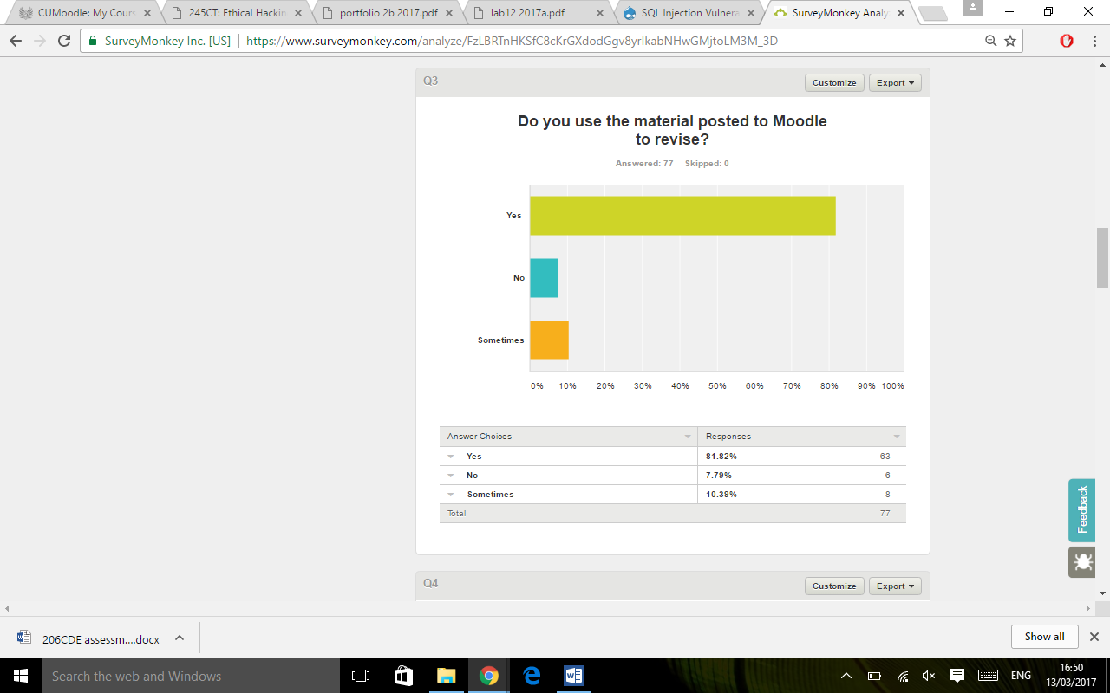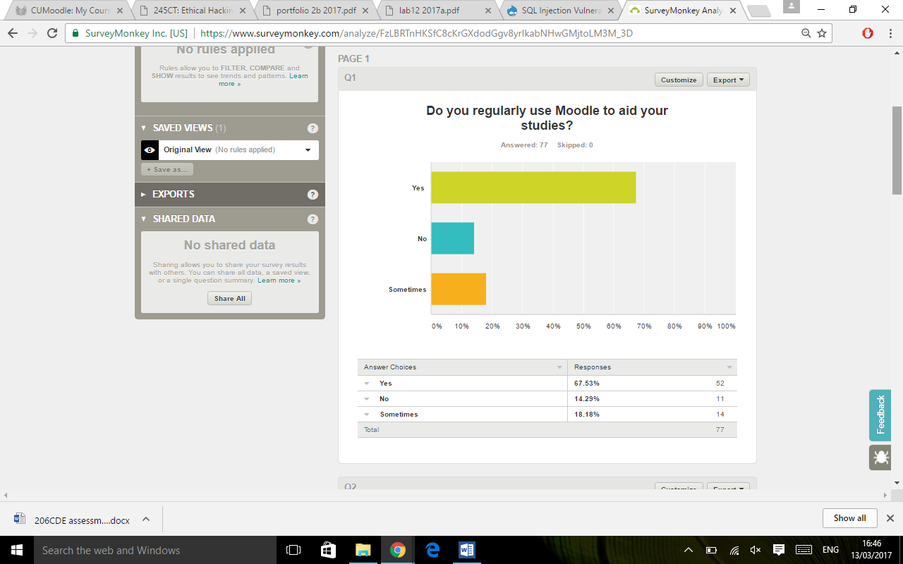target audience.

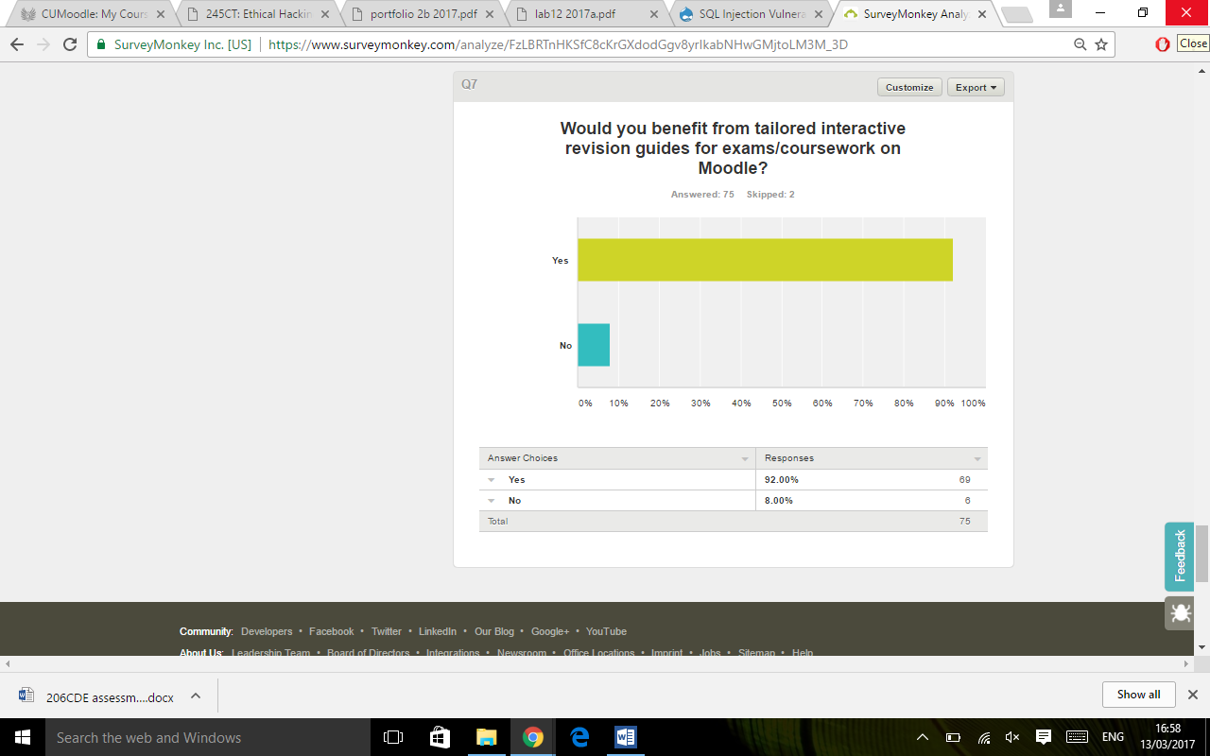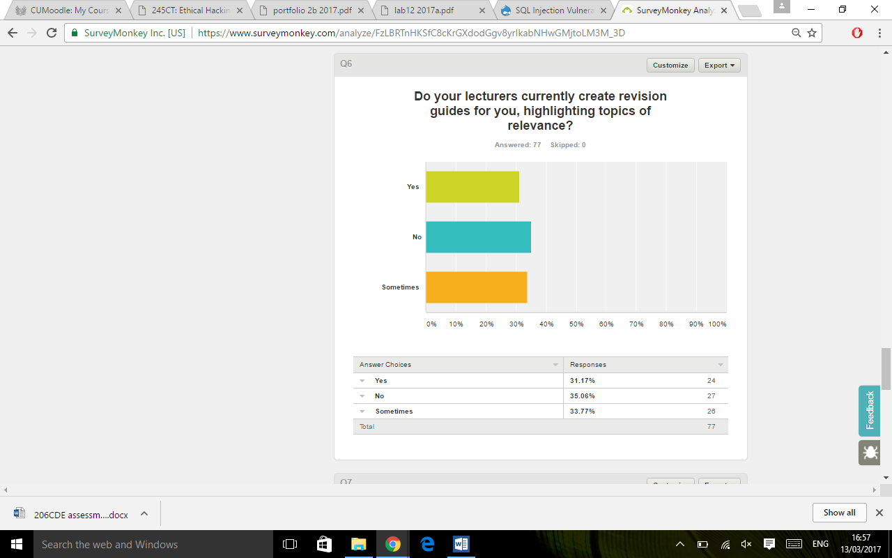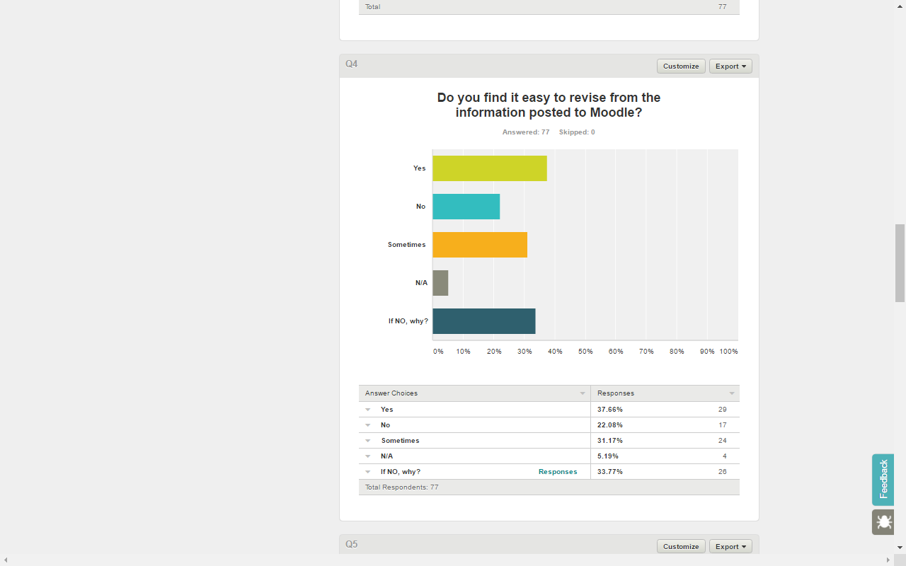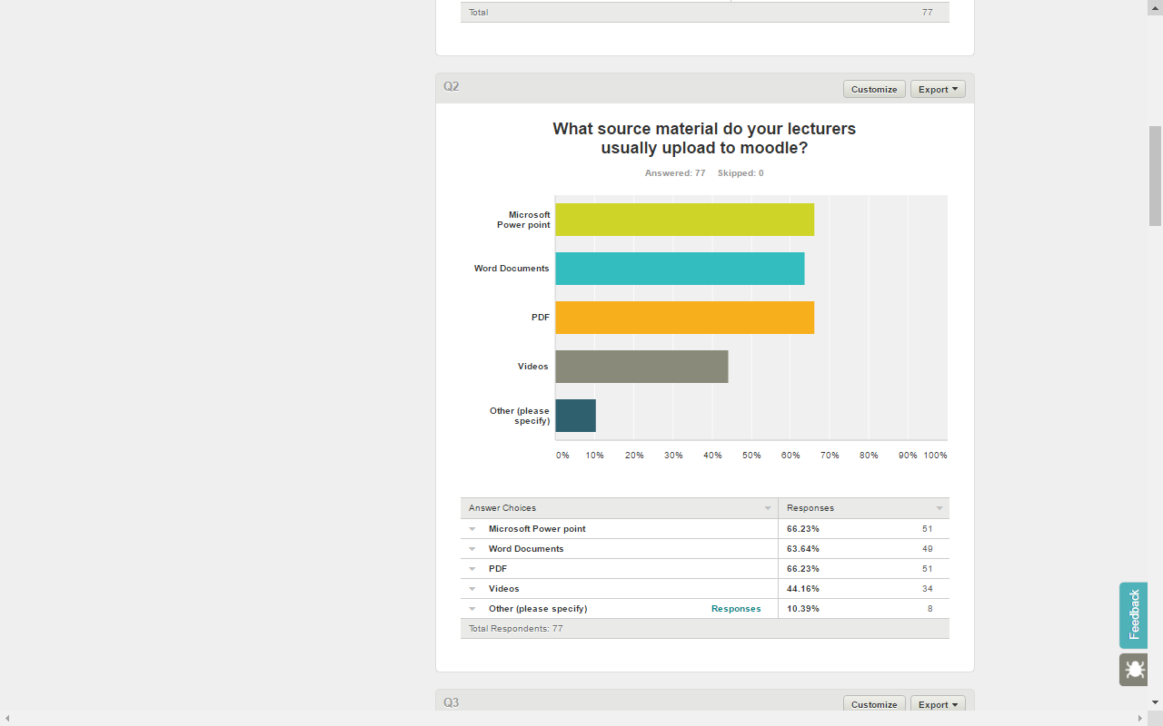

The survey we completed showed us that from people who completed the survey 86% use Moodle to aid their studies. 92% of people we surveyed said they used Moodle to revise for exams. With question 4 we found that although more people said yes. The majority of comments from ‘no’ and ‘sometimes’ showed that they struggle with the amount posted to Moodle and its not clear where documents/links are on the page. The survey also showed that lecturers do not currently create revision guides for students and this is something 92% of the students taking the survey said they would benefit from. From this survey we concluded that it is something that students do want, would use and would benefit from. From this we believe that the students and lecturers would benefit from the tool.

**Potential competitors.**

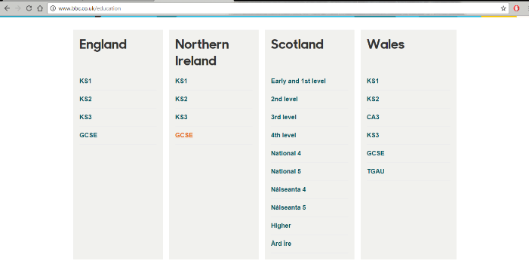There aren’t many ideas/systems like ours that are already online, the closest system that are already online and accessible are BBC Bite size and Cisco NATCAD online course. They both offer similar implementation of what we are trying to achieve, BBC Bite size offers courses from Key stage 1 to all the way to GCSE’s. Both have the similarity of selecting a course, within courses subjects can be selected e.g. for BBC Bitesize - Computer science & for Cisco NATCAD – Networks, when a subject is selected, topics can be selected. This is similar as to what we are trying to achieve, however we are aiming for more such as link on Moodle/each module, timeline for lists, quick links etc. to make revision quicker and efficient for students and it would be a Moodle extension, making it more time efficient and easier for lecturers as well by giving them access to add/remove each topics, control of timeline, add videos for efficient revision. These are the features that BBC Bite size and Cisco Nat cad do not offer to students and lecturers. We believe our idea/implementation is original and unique which we aim to achieve as a group.

**Contacting Moodle**

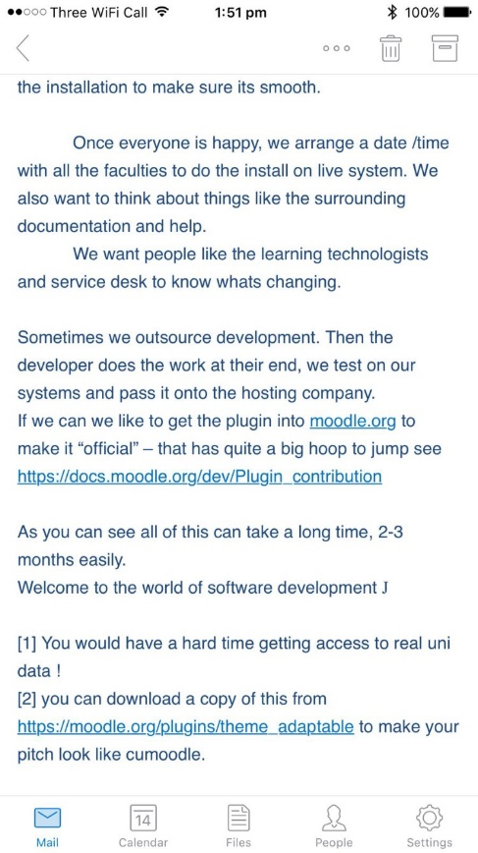We emailed Moodle Help desk to look into the rules and regulations around implementing this extension. What we would need to do to get this added to Moodle.

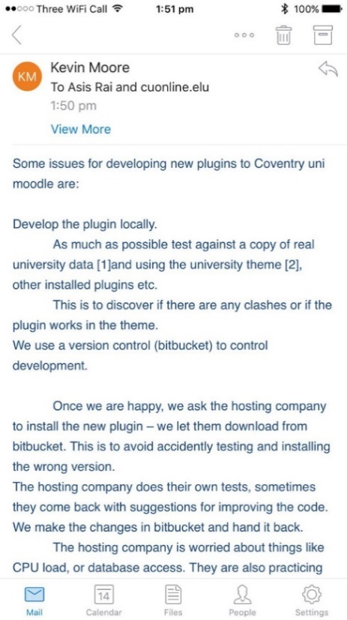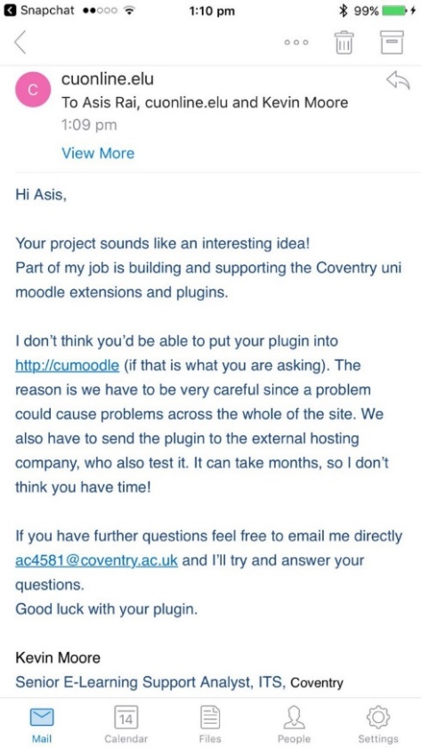

We looked the link that Moodle help gave us and summarised below what we would need to do.

**Requirement**

The plugin must be approved. Many institutions respect the approval review procedure and do not allow to install a plugin on their servers unless it has been approved in the plugins directory. So therefore in order to upload our extension into Coventry University Moodle, it has to be approved in the plugins directory.

**To start we would need:**

A Repository – GitHub for collaborative code within group members

Tracker - You are expected to have a system where users can report issues, bugs and feature requests for the plugin. We could use GitHub issues

Documentation - The plugin should have a good documentation available.

Screenshots - Prepare good screenshots that illustrate your plugin's essential features.

**Sharing code in the Plugins director**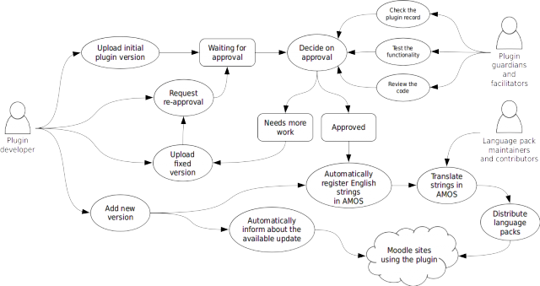

Once we have written a new plugin and want to share it now in the [Plugins directory](https://docs.moodle.org/dev/Plugins_directory): (Hoops to jump through)

1. We have to upload the initial plugin version for approval. To help the approval review go smoothly, We have to review the [Plugin contribution checklist](https://docs.moodle.org/dev/Plugin_contribution_checklist) and follow all the guidelines there.
2. After we submit the plugin for approval, it would take a week or two before we get initial review results. The Developers generally try and provide the feedback sooner, but it is not always possible. There are actual approval queue stats.
3. The plugin goes through the validation and approval process.
4. Almost all plugins are sent back as "needing more work" as a result of the initial review. It is natural part of the workflow but it is time we do not have to spare.
5. Once the plugin is approved, its strings are registered with [AMOS](https://docs.moodle.org/dev/AMOS) and can be translated. The plugin itself should ship with English strings only.
6. If we are working from GitHub, The plugin developers do not automatically pull from Github. We have to implicitly release new version via the Plugins directory.

**Registering a trade Mark**

The Preperator – talk about how we’ve checked if its been copy righted, how we can copyright it.

Since we created a name we looked at whether the name had been trademarked, it hadn’t and then looked into how we would trade mark the name and logo as seen below. We would also look at copyrighting our code to ensure that other companies could not use this for their own use.

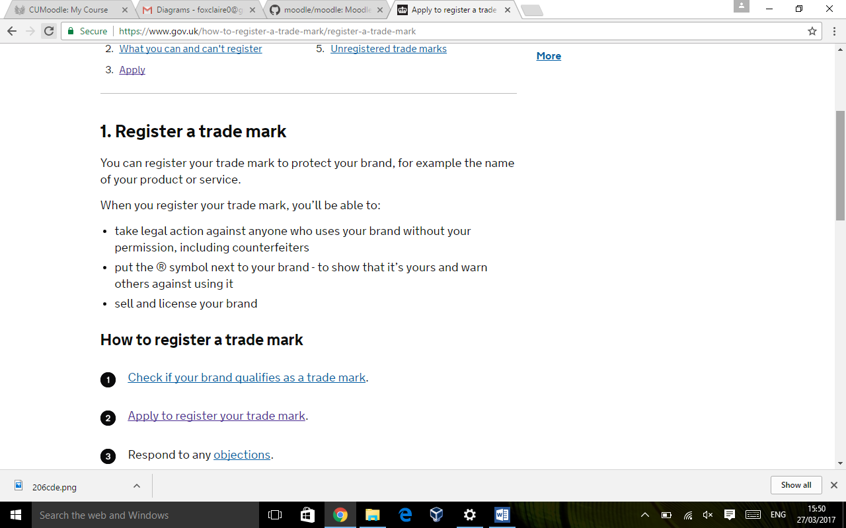

<https://www.gov.uk/how-to-register-a-trade-mark/register-a-trade-mark> (accessed: 27/03/2017)

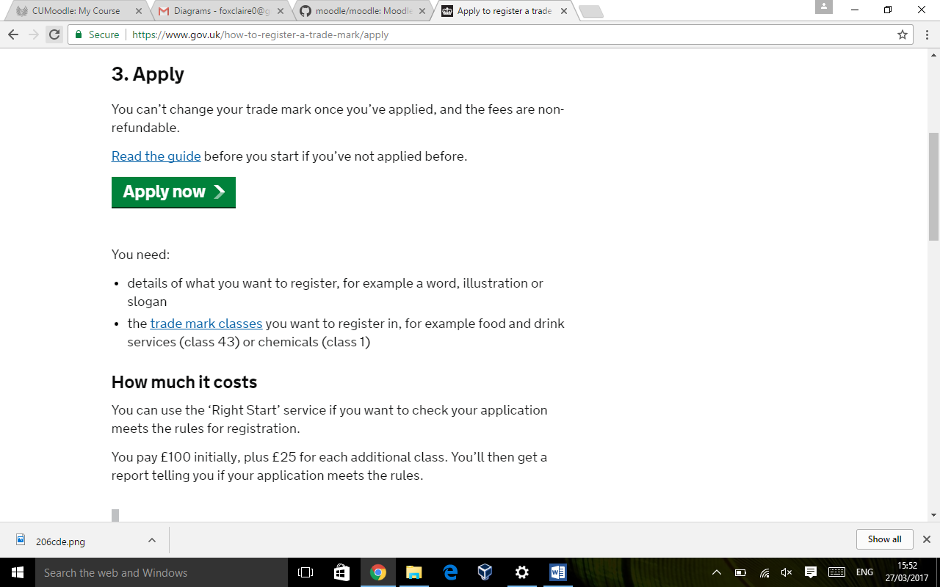

<https://www.gov.uk/how-to-register-a-trade-mark/apply> (accessed: 27/03/2017)

**Professional/Legal and Ethical considerations**

As a company we would have a duty of care for businesses using our product. We looked at various considerations for if we were to market this in the real world.

We looked in to the coding conventions and how we would consider these conventions when writing our code. We would undertake vigorous error checking and testing before launching this product to ensure customers would not be disappointed, and discuss potential security issues that could arise.

**Week by Week Plan** - 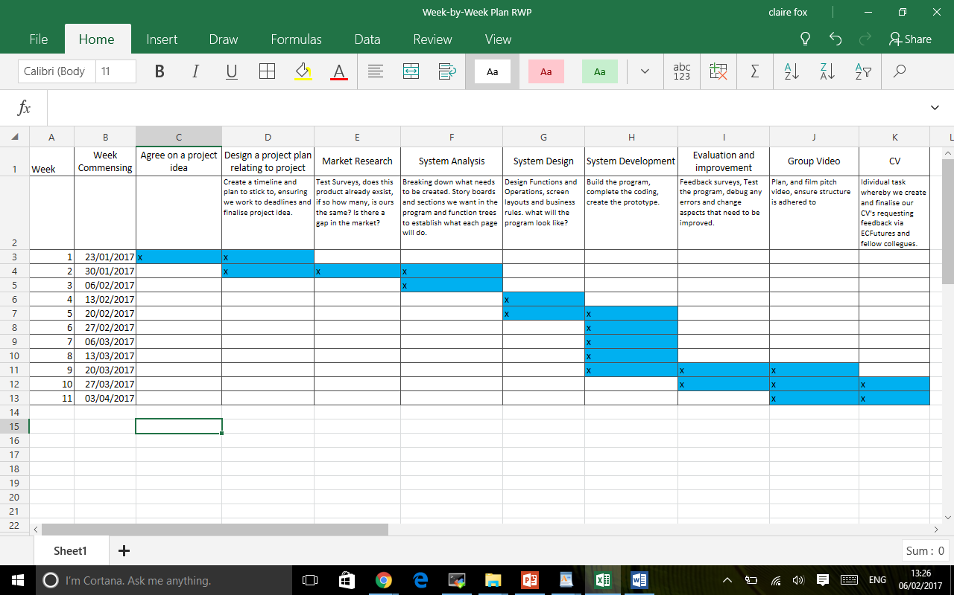

**Risk Assessment (Group Work)-**

Bad time management – Bad time management can lead to delays and risk of not being able to complete the project in time. This can affect us all and therefore we have elected a group leader. They will delegate jobs to each individual member of the group with tasks to do every week. We will also have an extra weekly group meeting to make sure that everyone is doing their part for the project and keeps us on track with project completion on time.

Individual delays – If a member of the group is not doing his/her work then it affects the whole group as the project is connected, it also makes someone else in the group do the work which wouldn’t be fair. To tackle this, if a certain member of the group is not producing his/her work then they will be spoken to by the team leader to determine why. (Other deadlines/sickness) if the problem is not resolved it will be reported to the Tutor and actions will be taken by the Tutor.

Absent group member – If a member of the group is not turning up in class and group member meetings then he/she is missing out on the tasks which is allocated to them and it will affect the whole group as they must catch up and they risk of not completing their work on time. To tackle this, if a certain member of the group is not turning up in class or group member meetings then they will be contacted by group leader/group member, if this is unsuccessful they will be reported to the Tutor and actions will be taken by the Tutor.

Hardware failure resulting in losing some/complete work – It would be devastating to lose some/complete work because of hardware failure. If this happens then we could fail the task because we wouldn’t have enough time to complete the work again. To make sure this doesn’t happen, each member of the group will have the most up-to-date backup copy of the project.

Certain part of the project proves too challenging – This will most likely occur to us at some point, either individually or as a group. To tackle this, we have decided to do weekly group meetings where we will discuss our work and help each other. If even as a group, we find certain parts too challenging then we will attend support group as a group and we will find the solution.

**Group Work**

In week one a project leader was elected. As a group we decided what needed to be done in order to complete this project. The group leader then created a week by week plan to ensure that we would completed the group project on time and also allow time for the individual report. Every week the project leader distributed tasks throughout the group that needed to be completed that week and then the following week checked on the progress of these tasks. We created a WhatsApp group to ensure that we could all keep in contact throughout the project duration and bounce ideas and concerns around, whilst also being able to update the group on attendance and if members were going to be late/absent for group meetings.

|  |  |  |
| --- | --- | --- |
|  | | **Week By Week progress** |
| Week 1 | | Group introductions (swapping contact details)  Electing a project leader (Claire)  Deciding extra group meeting day.  Discussing groups strengths and weaknesses and whether group members had ideas. |
| Week 2 | | 1. Established final project idea (thought of originally by Erik, idea developed by all of us.) 2. Project leader showed group members week by week plan 3. Looking at potential competitors and market research ideas such as surveys 4. Jobs for this week  * Johnny & Andrei- look at Moodle, how difficult it will be to implement, source code etc. * Claire- Create and publish market research survey * Erik-start to plan what we want the extension pages to look like * Asis- Market research (Competitors) |
| Week 3 | | 1. Project leader went through Project proposal forms to ensure whole group agreed on the information 2. Discussed tasks from last week. 3. Discussed potential issues with the project and how they could be overcome.  * Johnny-Look at what low level issues could be apparent and what we can do to overcome them * Erik- Design the lecturers view/story line * Andrei- Continue to look at android shell possibility * Asis- Complete group risk assessment/write up competitors * Claire – Look at legal/ethical issues regarding our project and start constructing pages for hand in |
| Week 4 | | 1. Recap on last week, check we are still on track regarding week by week plan 2. Created function diagram of both students and lecturers.  * Johny & Andrei- Make a start on the coding (both students have most knowledge surrounding the code) * Asis- Look at ideas for our pitch video * Erik- Mock up screen shots * Claire- Type up function diagram, add to and edit draft plan with what was discussed/SWOT analysis |
| Week 5 & 6 | Deadlines and other commitments these weeks meant group members were absent for group meetings but work was continued  Throughout. These weeks off were taken into consideration when looking at our plan to ensure we were on time.  Erik, Andrei and Asis met up on the extra group meeting times to create the basic screen shots. | |
| Week 7 | 1. Discussed what we still needed to complete and what had been completed so far 2. A new marking guide was issued so we discussed what else needed to be done to meet the grading criteria.   Members of the group were missing in this session.   * Asis- email Moodle to look at what needs to be done if we were to implement this extension to Moodle (rules and regs) * Andrei- Create usability questionnaire for feedback. * Claire- write up week by week progress, add and write up survey analysis * Erik- ABSENT -Check on Mock up Screen shots. * Johnny- ABSENT (contacted regarding his development with the project) | |
| Week 8 | * 1. Discuss pitch idea plans, what will be in it,   2. Create a product name   3. Check in on absent members * Claire- Copy right research, regulation write up, look at how you copy right. Continue to modify and add to business   plan/Interface pages.   * Johnny- ABSENT, contacted again regarding Code Development * Erik- Send mock screen shots, create logo and tag line, * Andrei- Usability questionnaire. Diagrams. * Asis- create pitch video questions. | |
| Week 9 | * + 1. Make a start on pitch video     2. Run through interface pages to discuss last minute improvements  1. Discuss with group what is left to do. Due to members absent code was not developed as   Planned after several attempts at contact, so discuss contingency plan.   * Claire – Write up improvements discussed on the interface pages. * Erik – continue with pitch video * Johnny – ABSENT (contact made AGAIN) * Andrei - java code prototype. * Asis – step by step guide for lecturers.   Thursday meeting: voice overs for pitch video, finalising video | |
| Week 10 | * 1. Continue with pitch video   2. Make final edits to the interface and supporting pages.   Attended: Claire, Erik, Asis, Andrei | |

**Functionality Diagram**

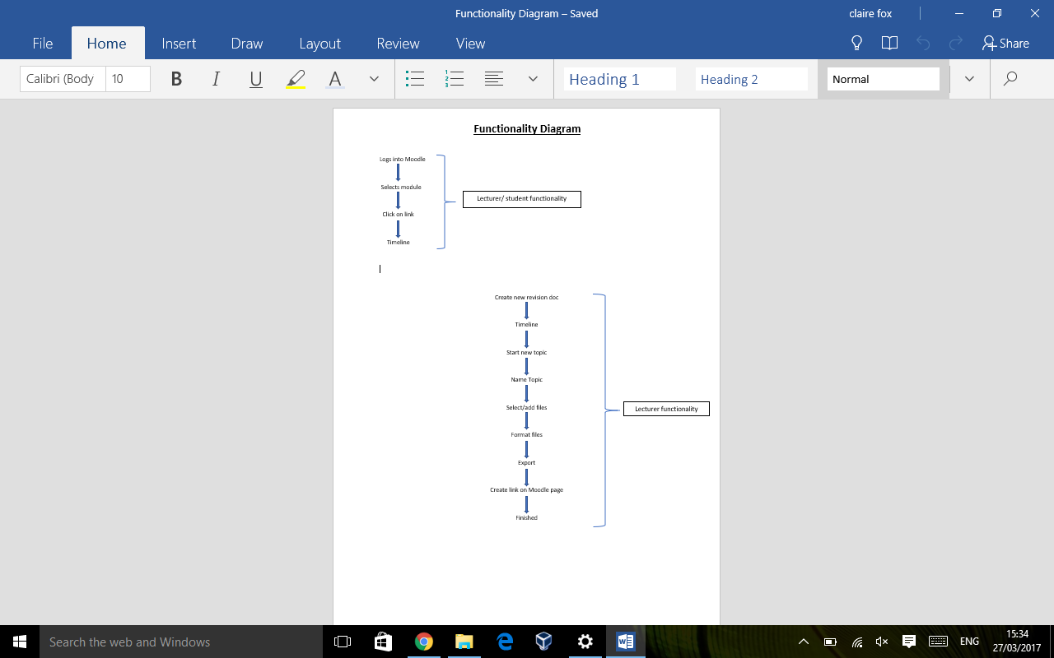

**Use Case Diagram**

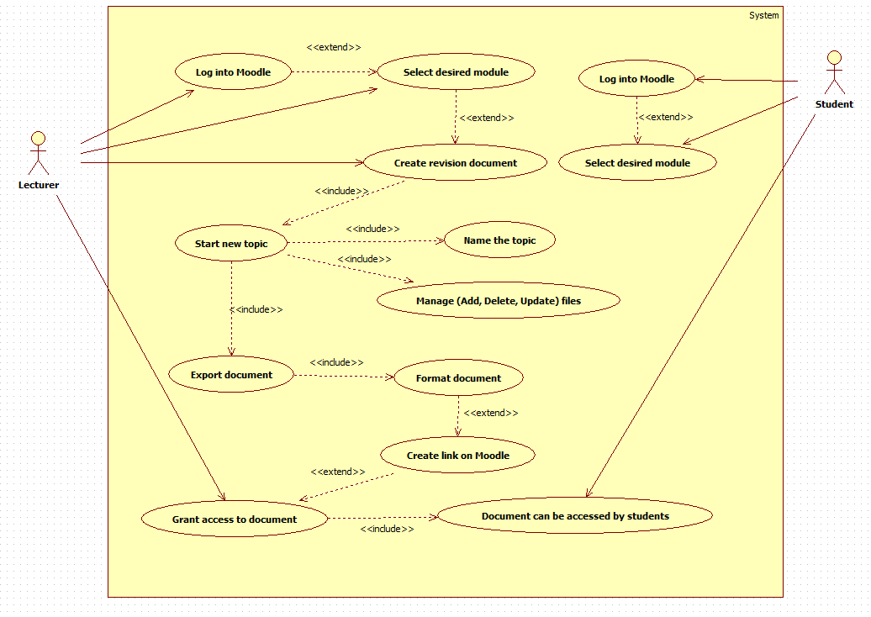

**Mock Screen Shots**

We have created an app version of the extension in Java to test a working version. We have added the source code as an additional zip file. If we had more time to develop this we would look at transferring this code to work on windows.

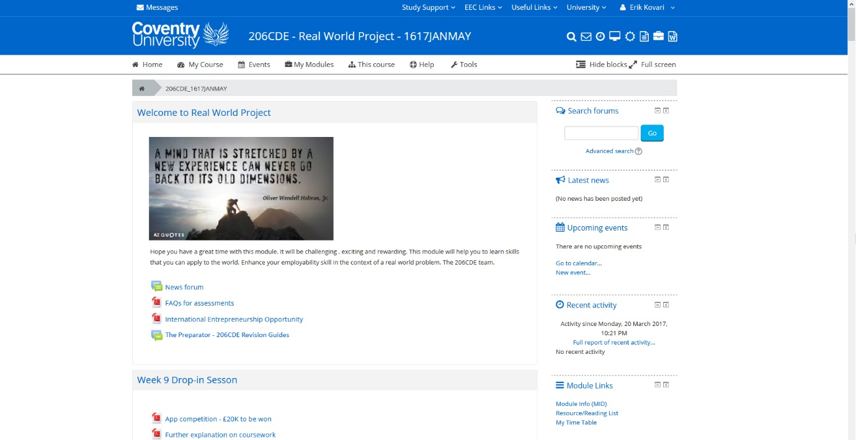

This Moodle page is what you see on a daily basis (Individual Module page). The link highlighted in red is the link to the Revision extension.

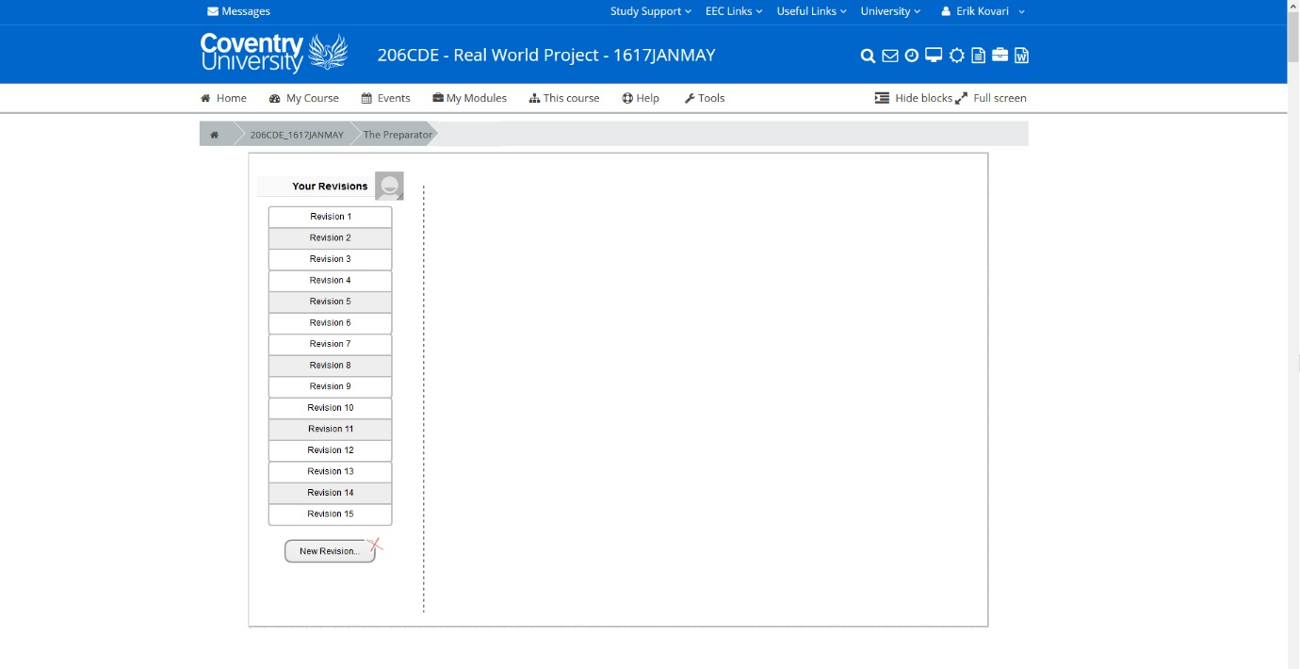

This is a lecturer’s view of the Preperator on this page it allows you to create a new revision (topic).

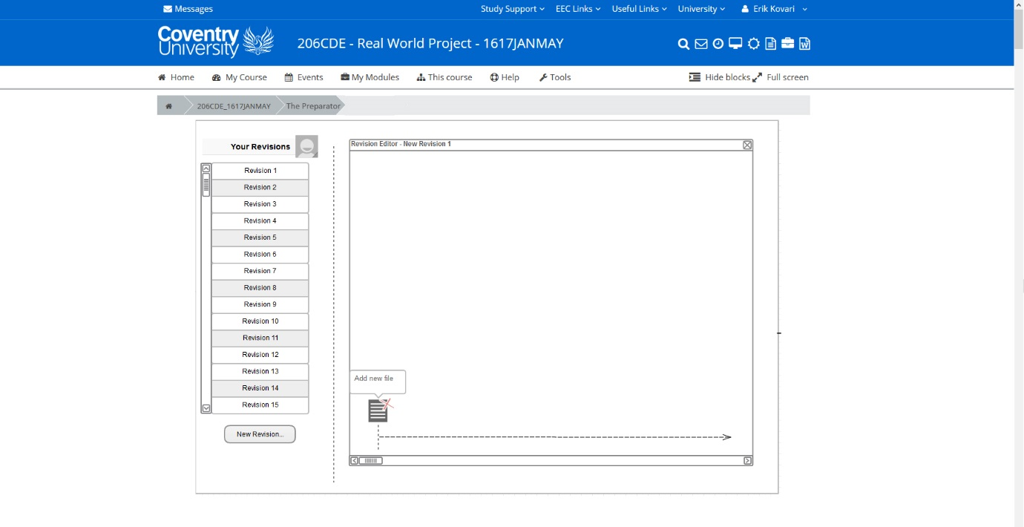

After clicking on a new revision you will be able to add new files/parts of a file to the timeline. The purpose of the time line makes it easier to see when topics have been taught and makes it easier to find.

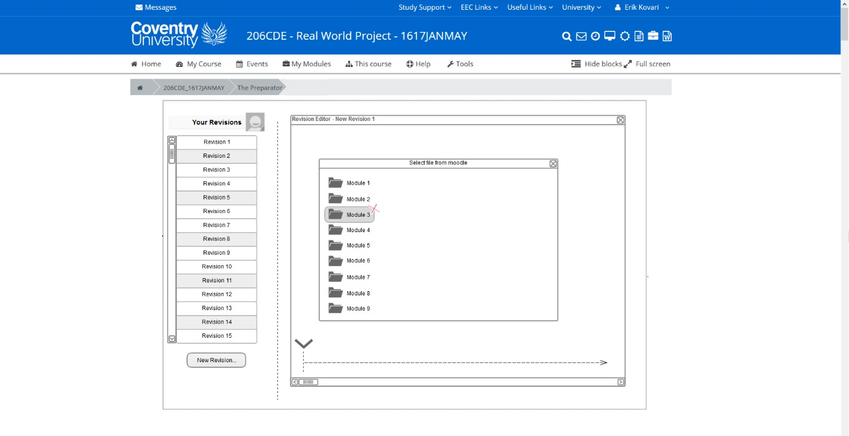

This page allows you to browse the Moodle directories and select the one you want.

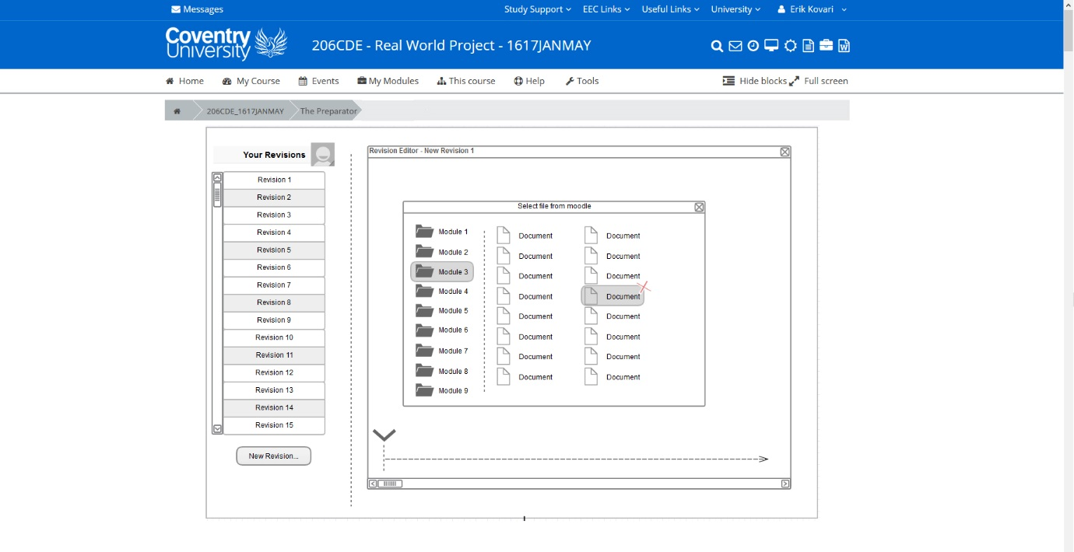

This page allows you to select the files you wish to add information from.

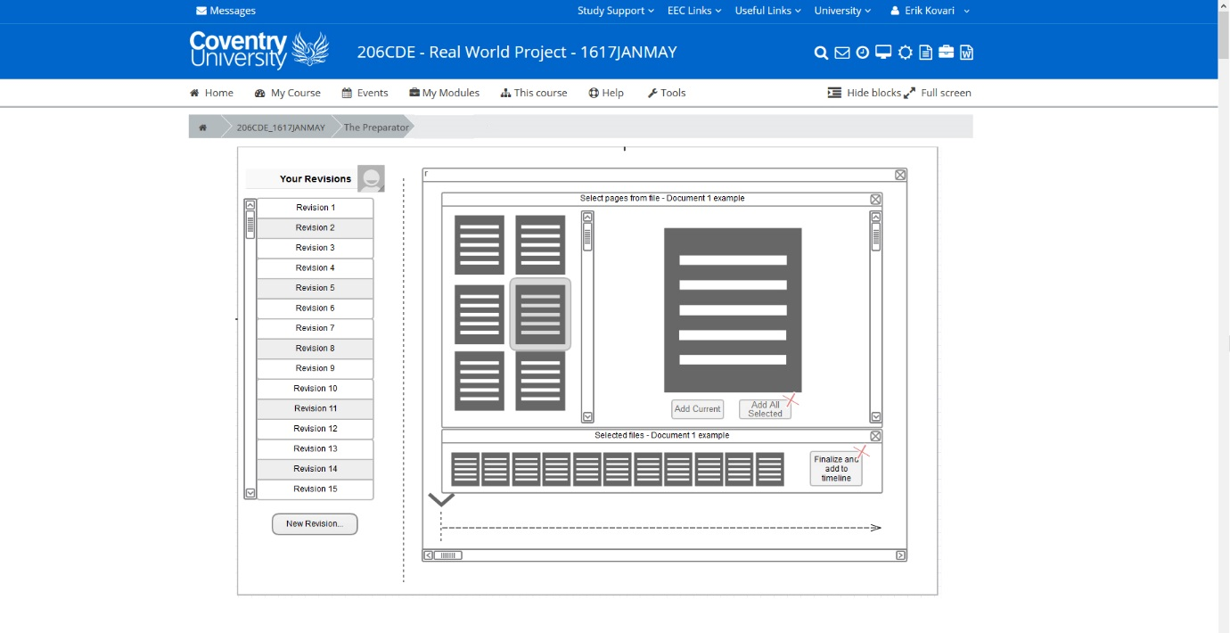

Once you’ve selected a document, you can drag and drop pages that are relevant to create your revision PDF.

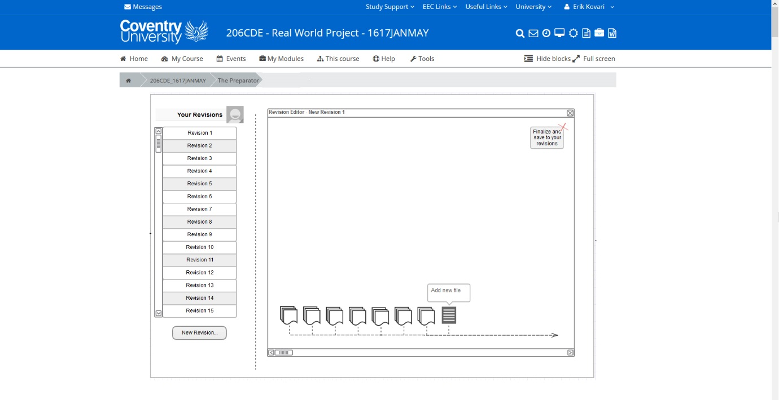

Once you’ve selected all the pages you wish to add to this topic at the time, you save this and it appears on the timeline, it then gives you the option to either create a new topic or finalise and add to Moodle.

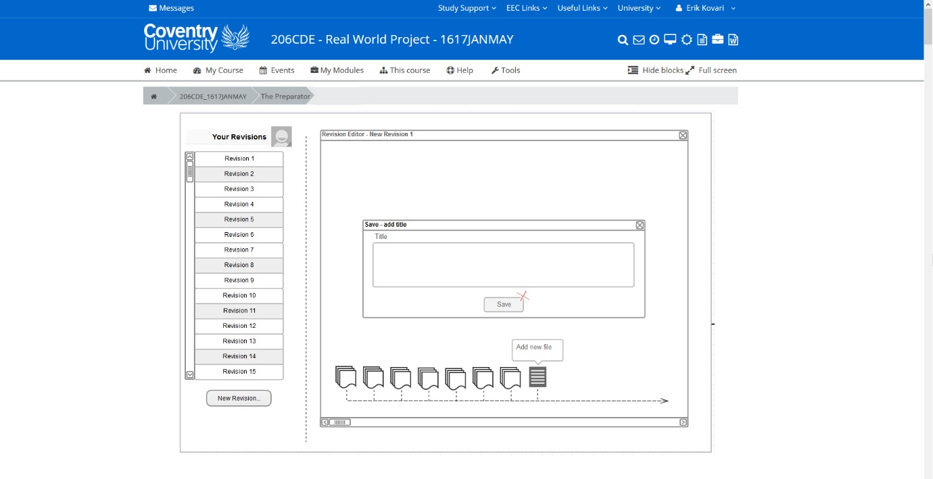

This is the ‘revision save’ page, this allows you to name your PDF revision files accordingly.

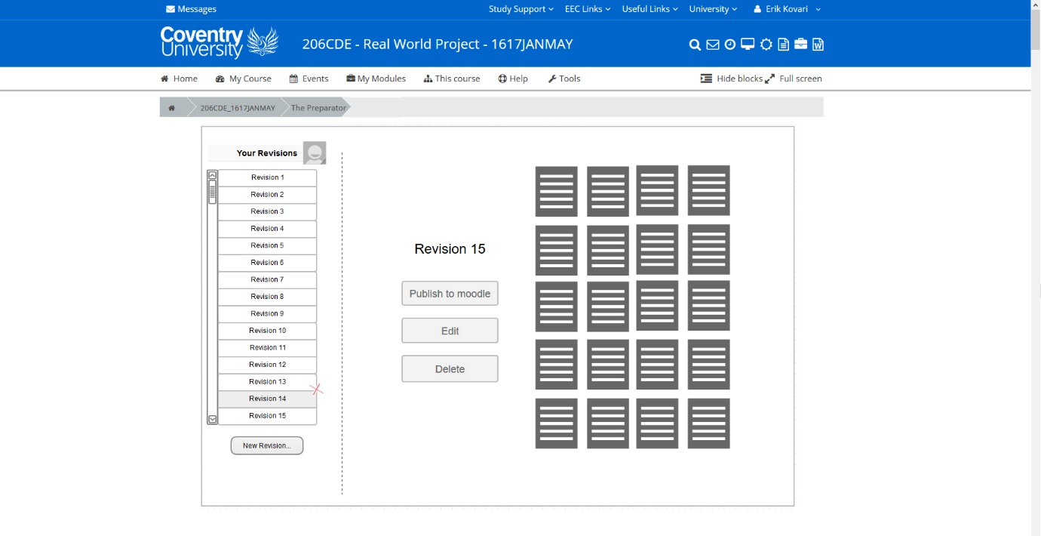

This page then allows you to publish your finished document to Moodle. So when students click the link this PDF will be present.

**User guide**

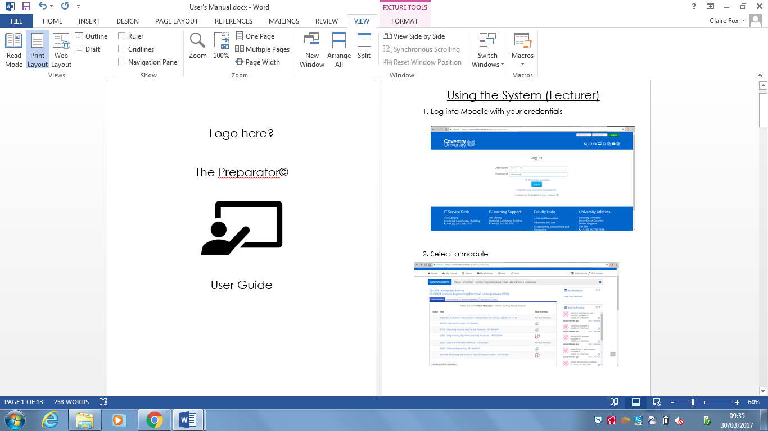

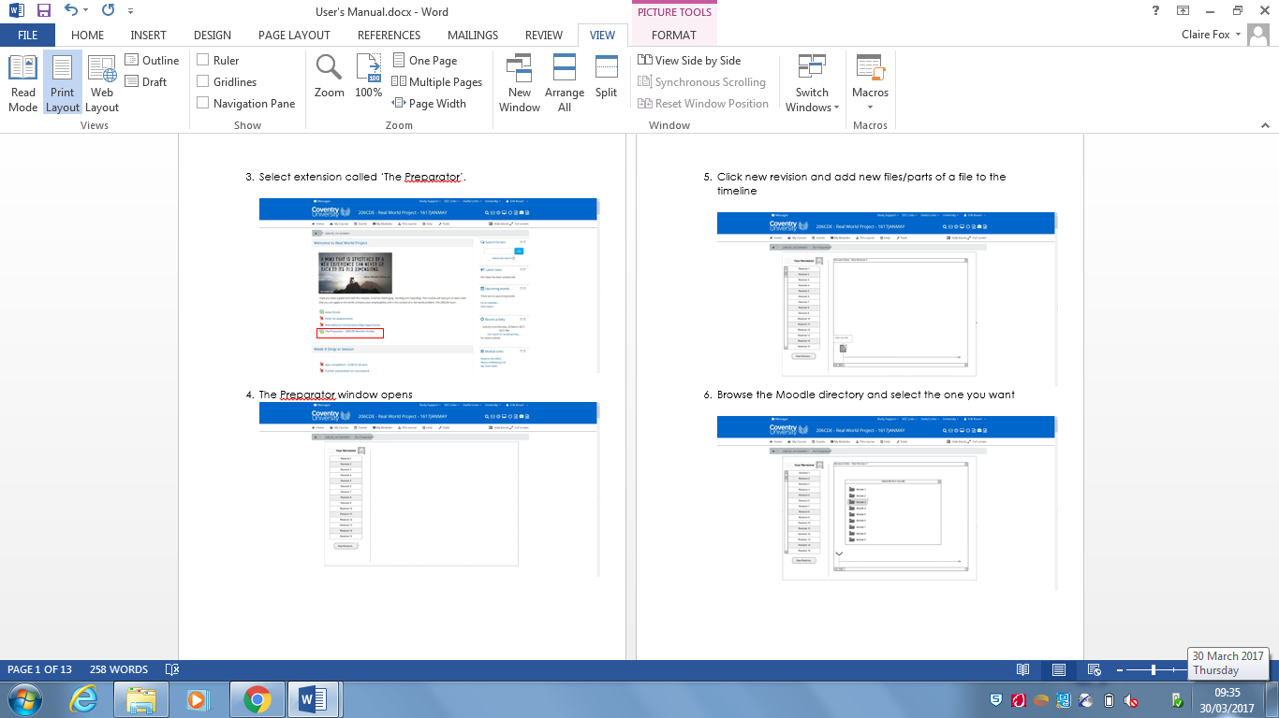

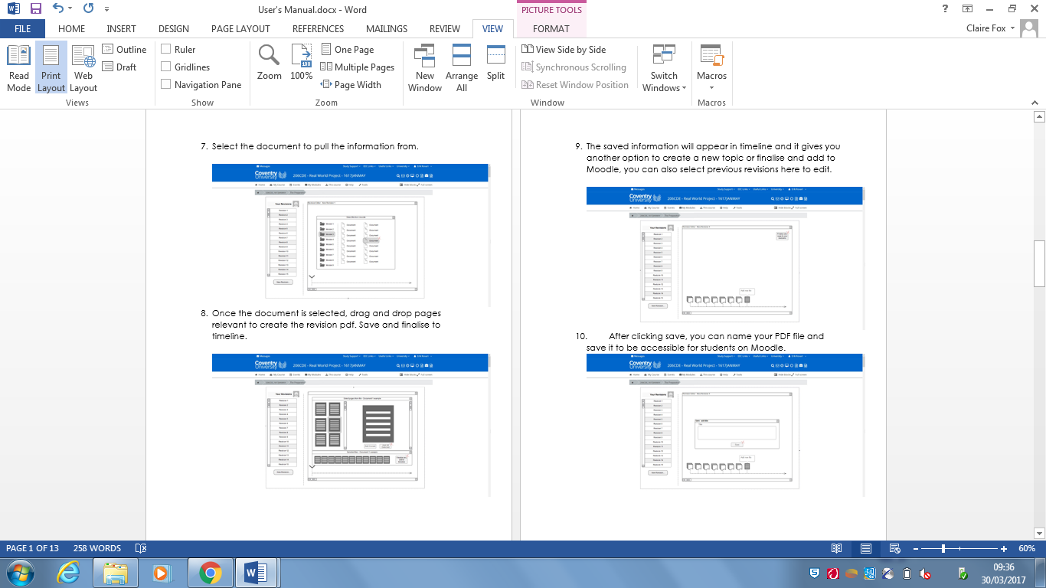

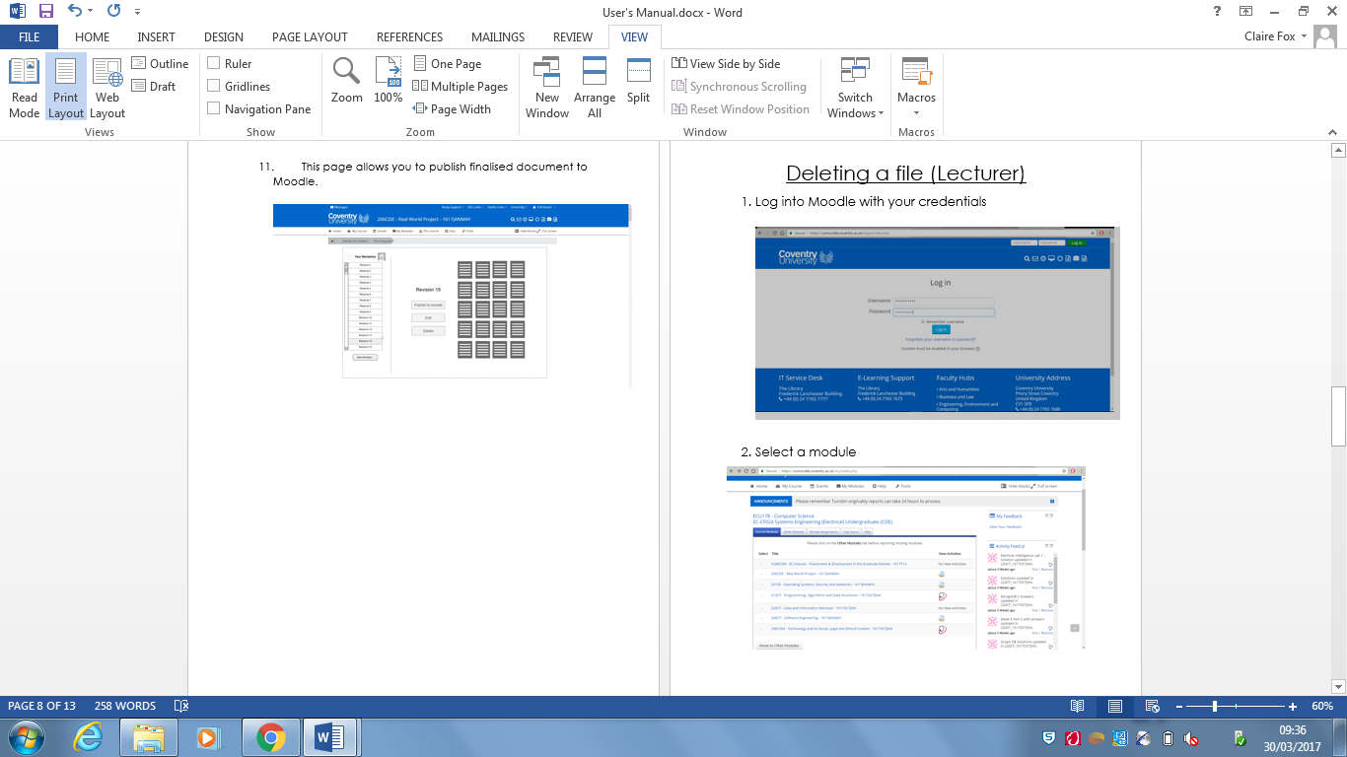

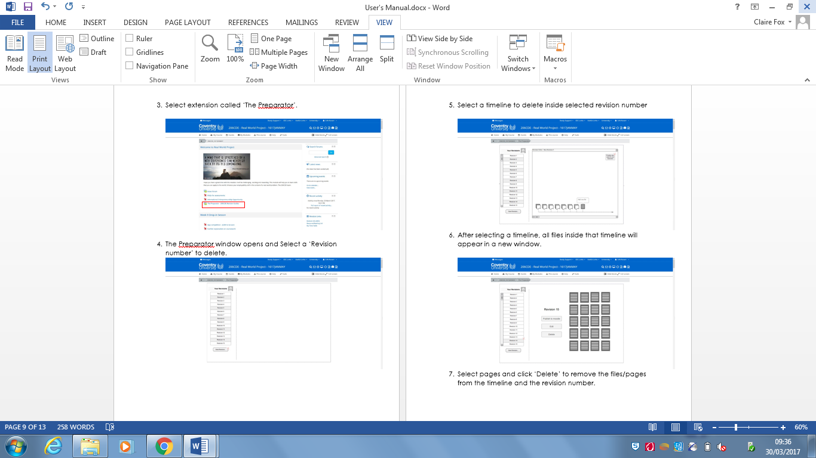

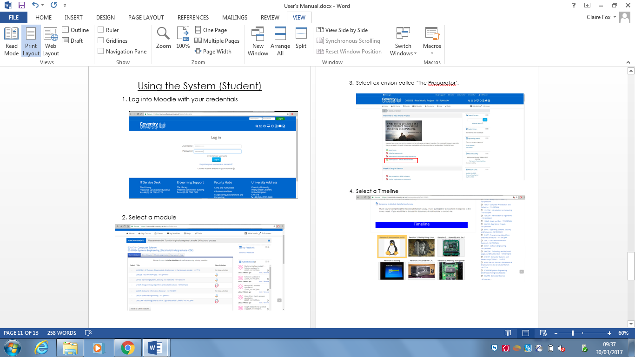

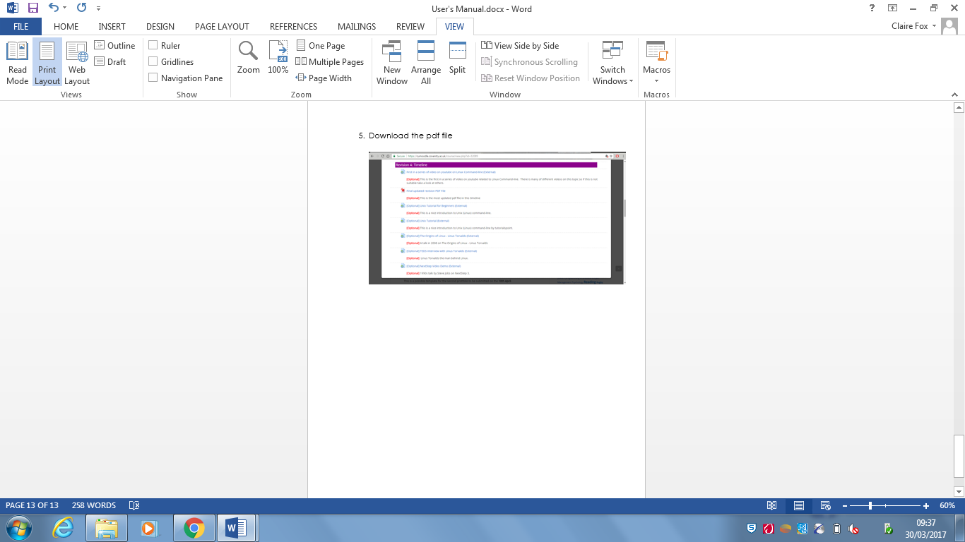

**Feedback Questionnaire**

Although we did not have a PC working prototype we asked students to look at our Screenshots, user guide and our functioning Mobile app and asked for their feedback. This would aid us if we looked at improving and developing the product.

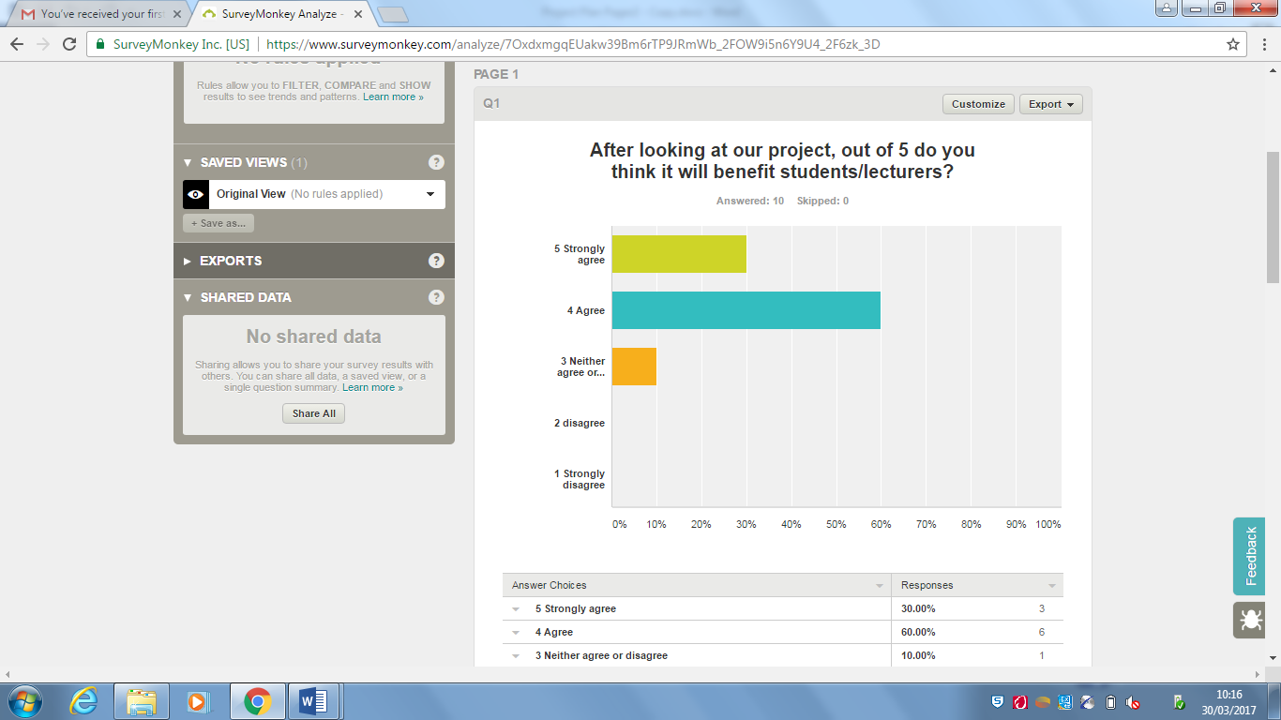

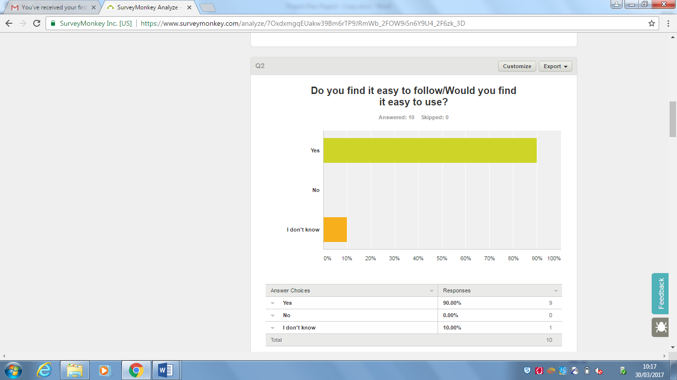

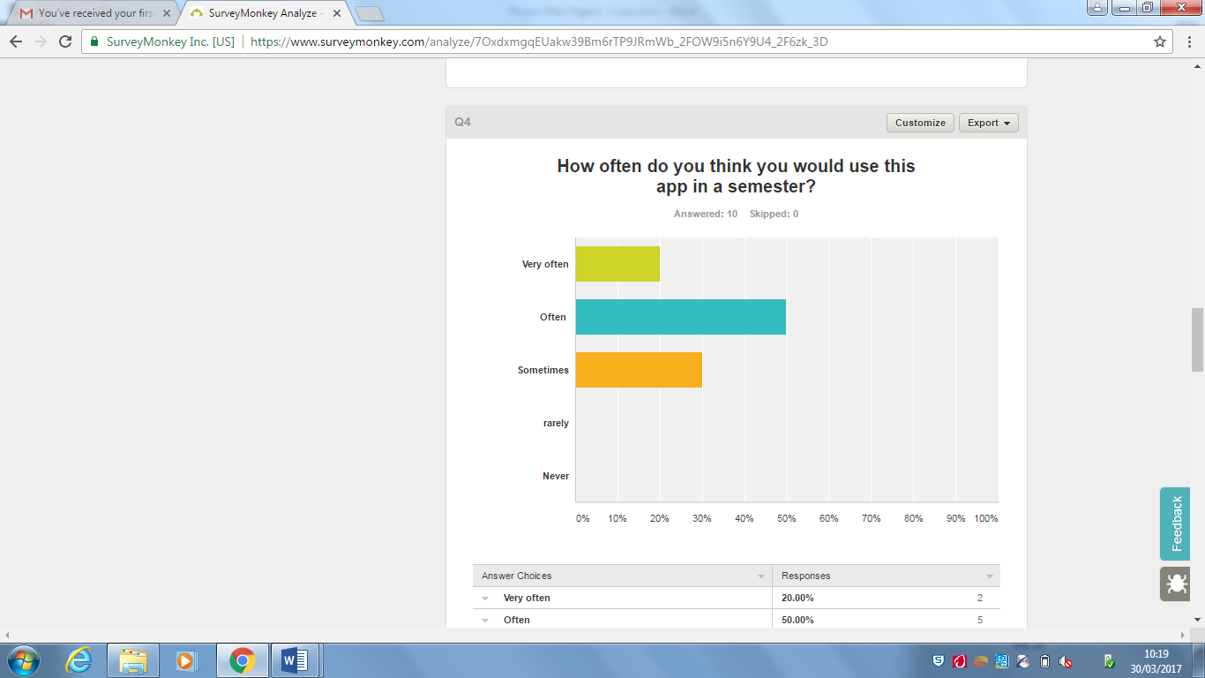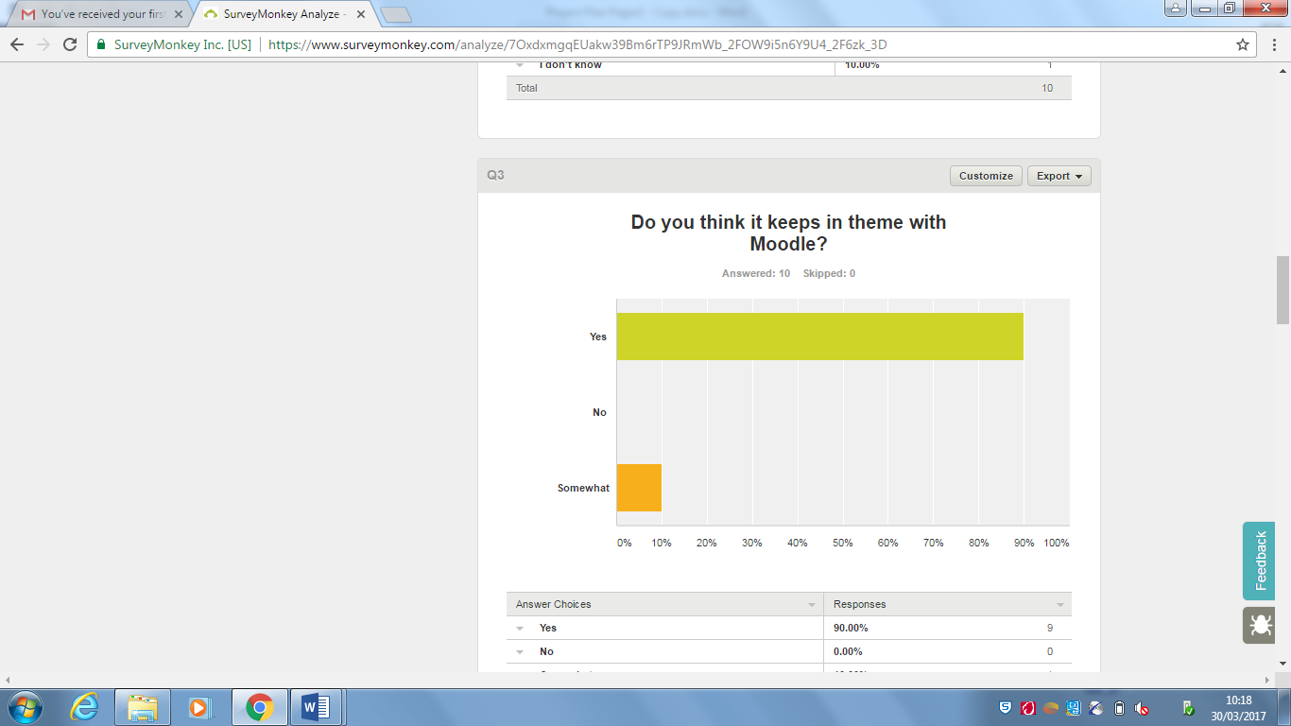

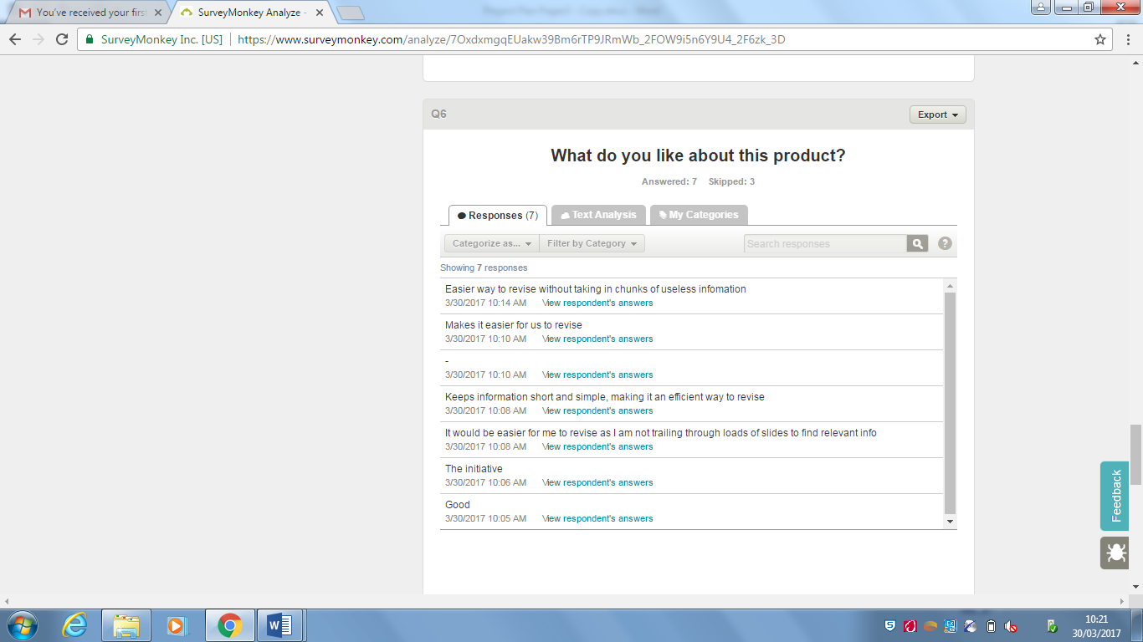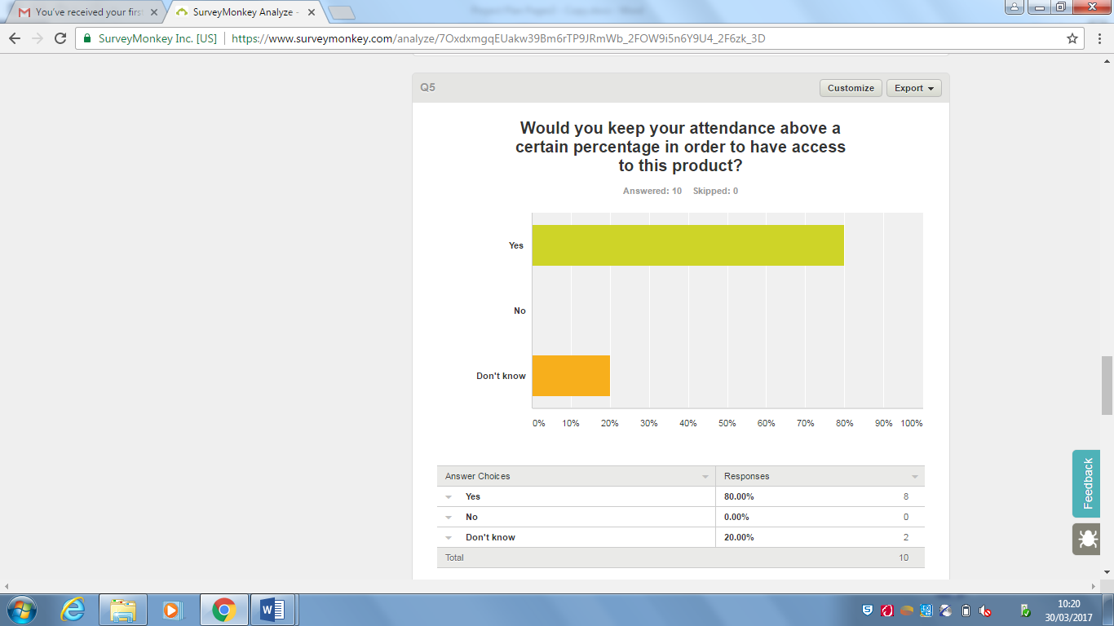

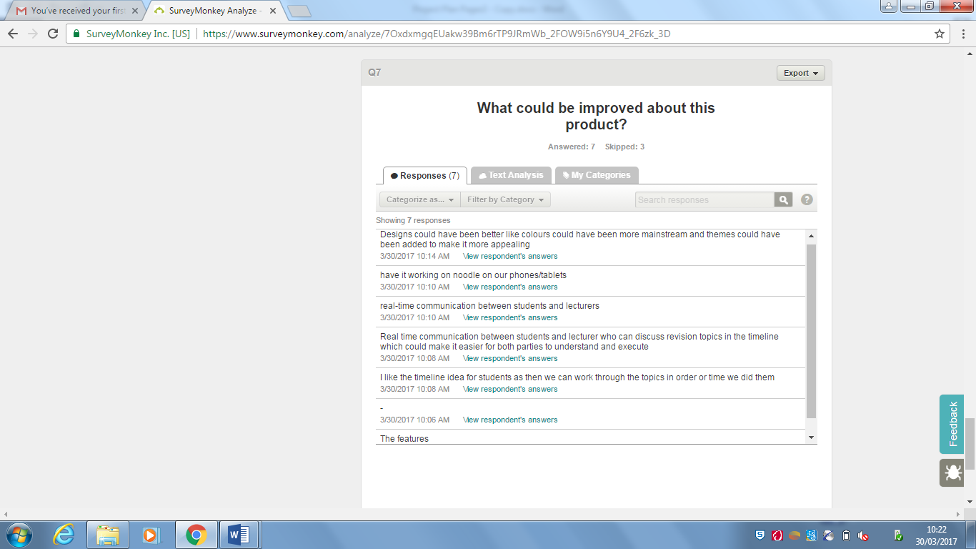

From this survey we have concluded that with regards to appearance it matches themes with Moodle. The people we surveyed liked the ease of the app and have said they would find it easy to follow. For improvements we would look at testing the app on the mobile site to see how it performs and then developing it to work on a mobile.